Pavanputra Infrastructures

A
Unit
Of

Lav–KusH
CONSTRUCTION

Pavanputra Infrastrutures
We do not blow our trumpet, but our work do contact : 9224488552

BMC.LINCENCED No: B/21/SS-1
BMC. LINCENCED No: B/204/SS-2
TO,

Dear sir,
We take in great pleasure by introducing ourselves one of the most reputed civil contractors in all over Mumbai (Bombay). We do undertake building Restorations, constructions, Tiling Work, building Repair, Waterproofing, Interior and Exterior Decorations, at a very competitive and reasonable rates.
We professional experts and have experience of over 35 years in this field. We have completed Building, civil planning and repairing jobs of prestigious companies, societies.

We list here below some of our few projects.

In the year 1987- 2024
- Riddhi Siddhi constructions Pvt.Ltd 1987-1989.
- Tivoli constructions Pvt. Ltd 1989- 1991
- Marve constructions Pvt. Ltd 1992-1994
- Ashish group & Realtor Pvt. Ltd 1995-1998.
- The Nutan Laxmi Co-Op-hsg. SocLtd. 1997- 1999
- Matelreeds Milestone &Marft. Ind. 1999-2000
- The Borivli Vishu Co-op-hsg-soc Ltd. 2000-2001
- The philjoy co-op-hsg-soc Ltd. 2000-2001
- The Akhilbharat Versiya Marwani Agarwal Jatiya Khosh 2002-2003
- R.N.A.(A.A)Builder. 2003-2005.
- Altana Pharma Ltd.(R&D) 2005-2007 ( B .E. Billimoria ) PMC
- B.E.Billimoria and Company Ltd. 2008-2010
- Ameya Groups. 2010-2019
- MUMBAI METRO STATION 2019 ( J.KUMAR ) EKSAR METRO STATION.
- M/S Bharat Infra & Engg.Pvt. Ltd. 2020 - 2021
- M/S Unwal infra pvt. ltd 2021-2024

We shall be thankful to you, kindly enlist our names in your record sand contacts us if there any building constructions, painting, tilling, Interior and Exterior decorations or building repair work.
Assuring you of our best service all the time and thank you to you once again in advance.

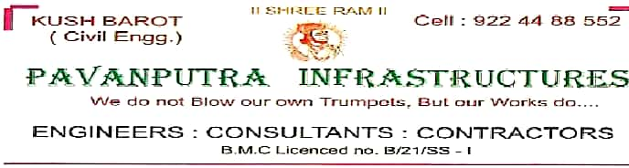
Pavanputra Infrastrutures
We do not blow our trumpet, but our work do contact : 9224488552

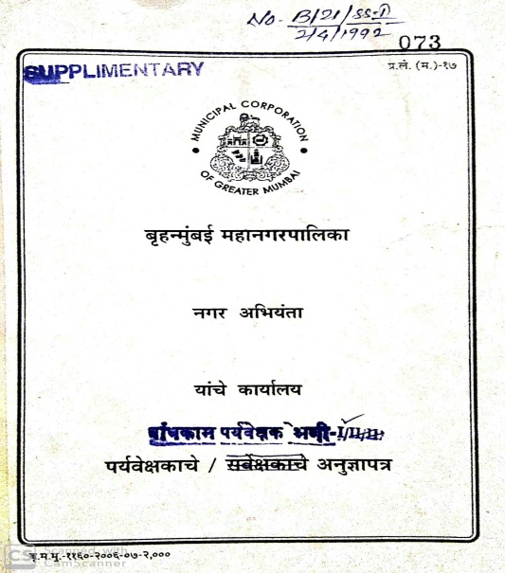
B.M.C. ENGINEER LICENCED
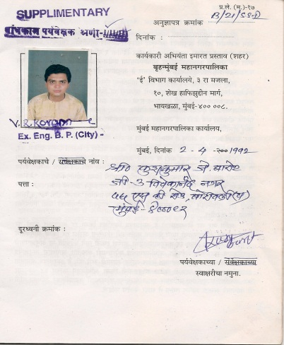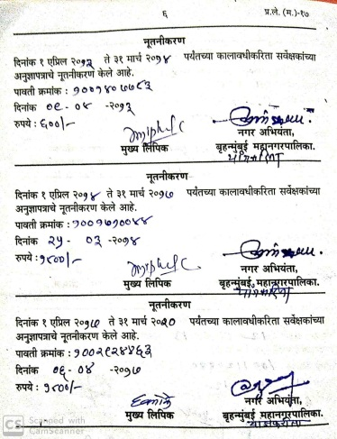

We have following constructions Equipment.
M.S. Jack props. = 1000 Nos. + M.S.Acrow span = 500 Nos + Concrete Mixture = 02 Nos +Materials Lift.- 01
M.S. H-Frames.= 800 Nos + Vibrator = 02 Nos + .Bending machine.= 01Nos + Centering materials =500 sq.ft
Strength of working staff.
Site JR,SR Engineers. 04 Nos +.Foremen = 04 Nos + Supervisor= 03 Nos. + Reinforcement Foremen= 03 Nos
.Shuttering Foremen = 03 Nos.+ Site co-coordinator = 01 Nos. + R.C.C Consultant = 02 nos. + Design Architect = 02 nos.+ Interior Design Arch. = 03 nos.+ MEP Engineer = 02 nos.+ Surveyor = 02 nos.+ Tender Document engineer = 01 nos
Pavanputra Infrastrutures
We do not blow our trumpet, but our work do contact : 9224488552

ACTUAL SITE PHOTO
B.E.BILLIMORIA , Mahindra splendor AT BHANDUP (W) PARIWAR CHSL ( AMEYA GROUPS )

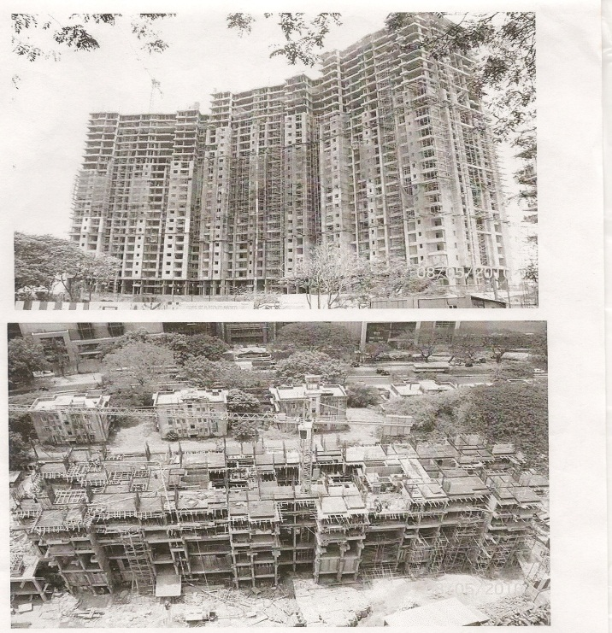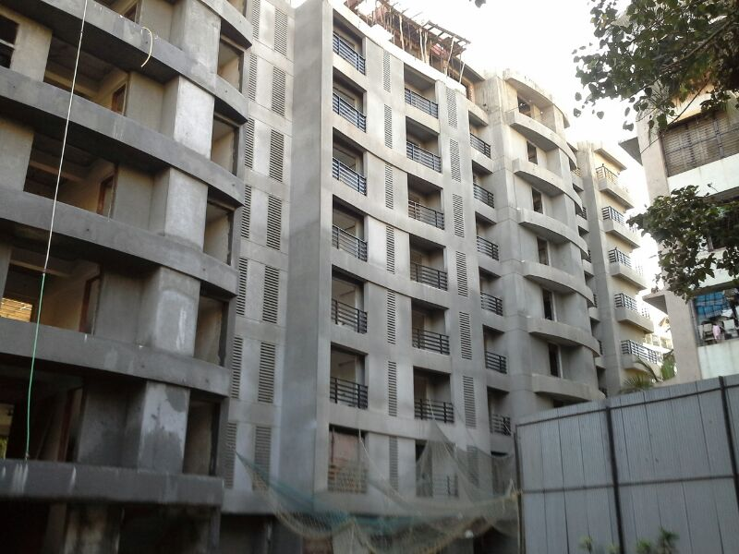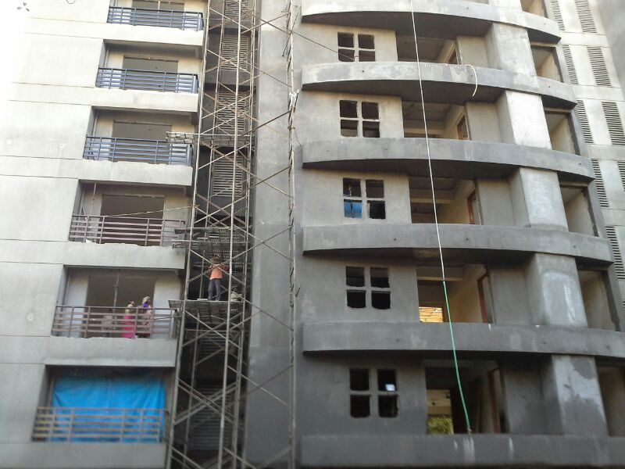

Pavanputra Infrastrutures
We do not blow our trumpet, but our works do

EKSAR MUMBAI METRO PROJECT AT BORIVALI (W) MUMBAI 400 092.FROM J.KUMAR
Cement Concrete BLOCK WORK.
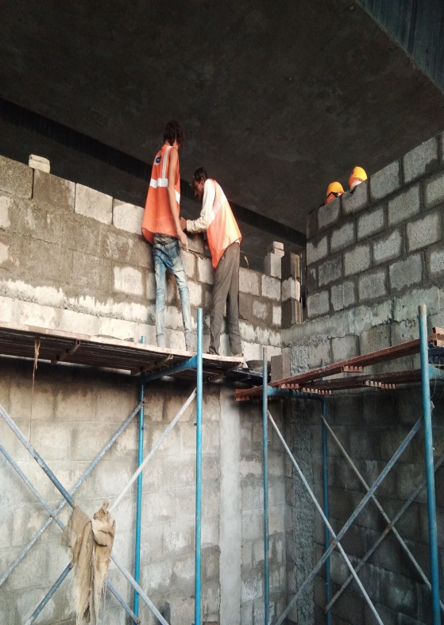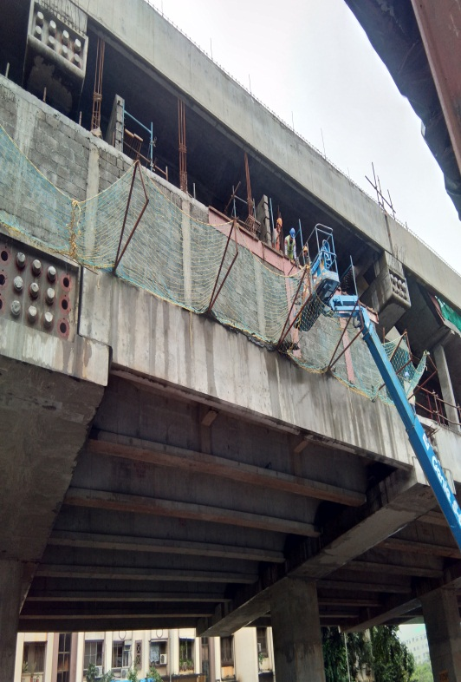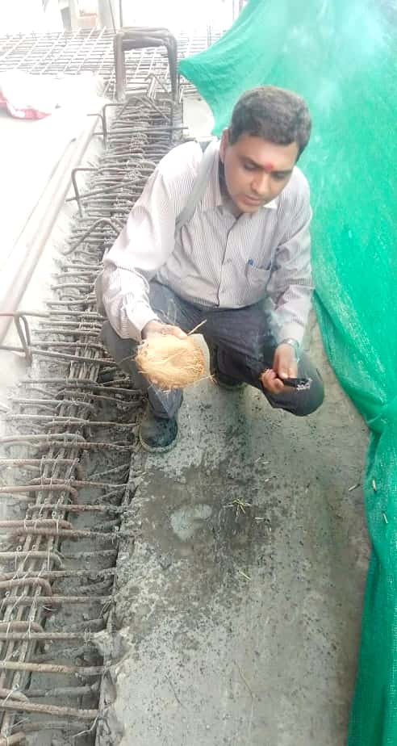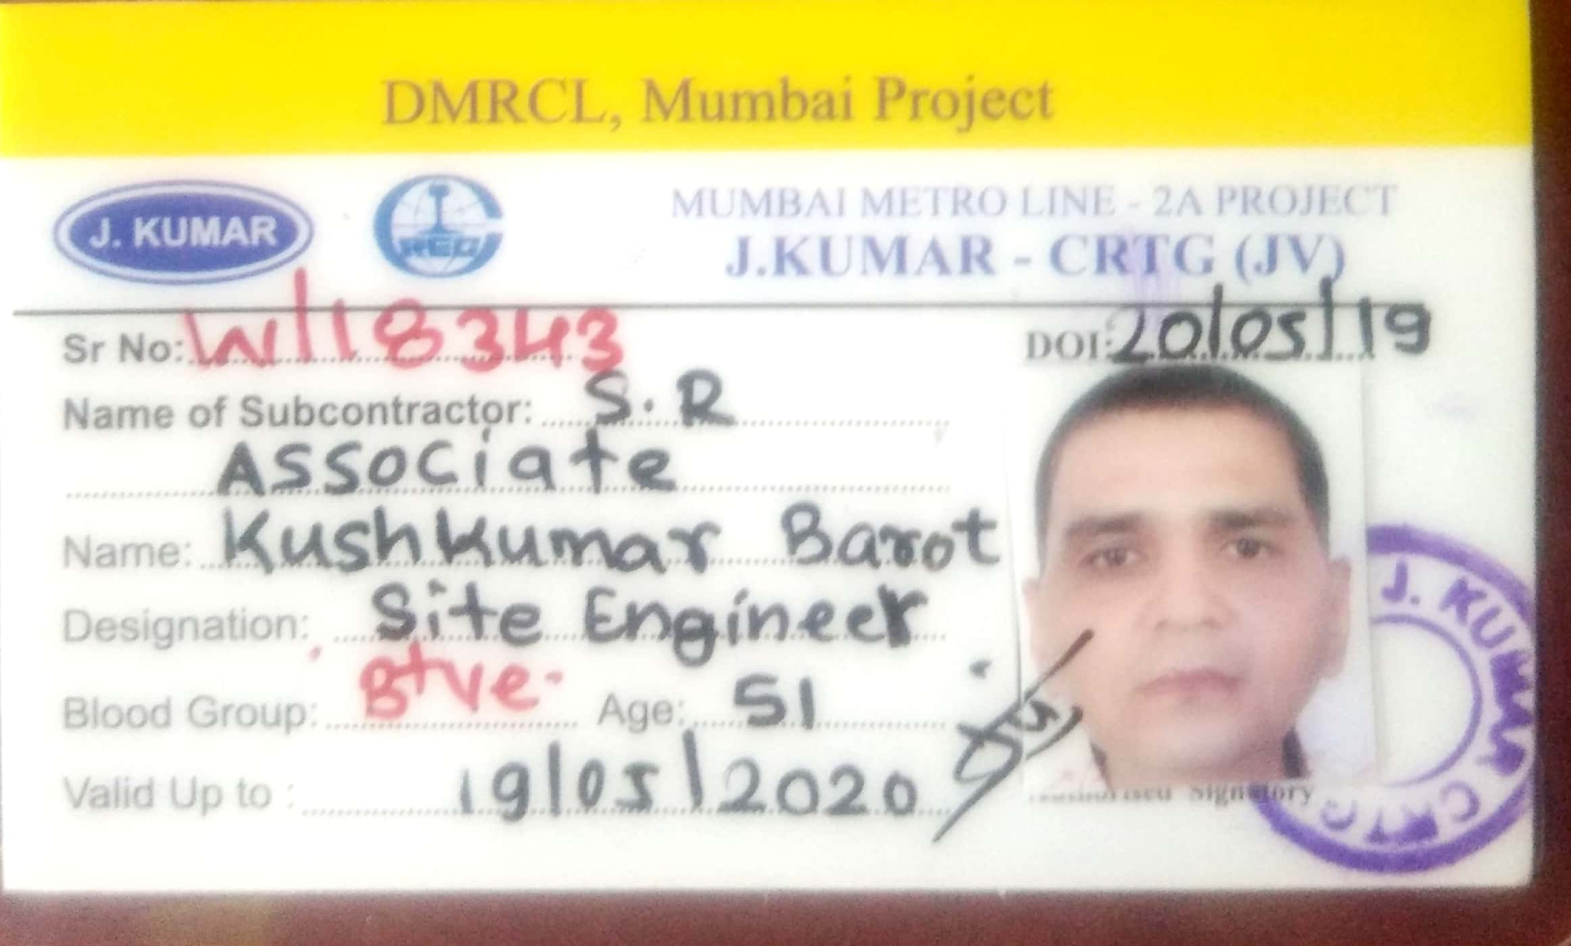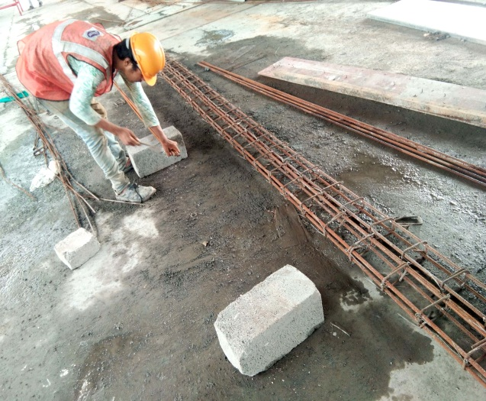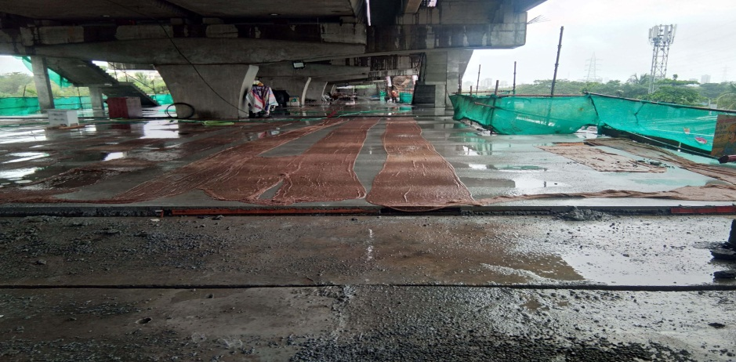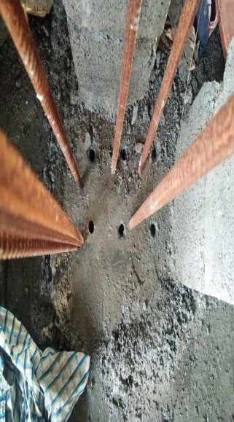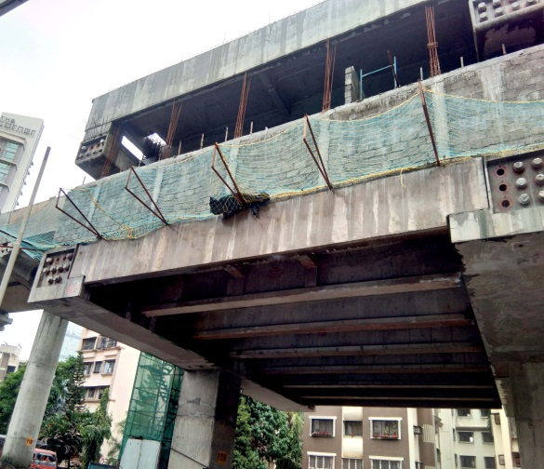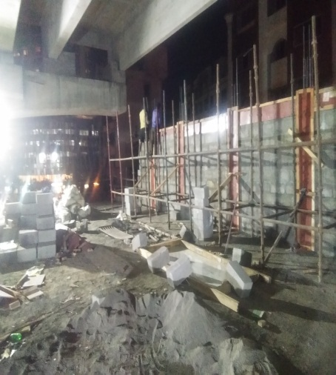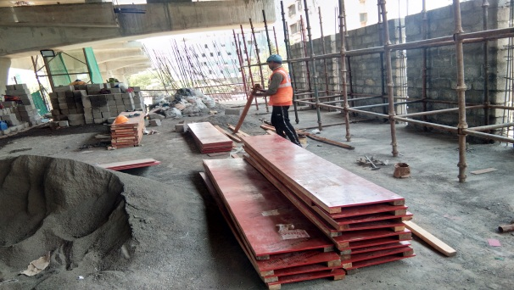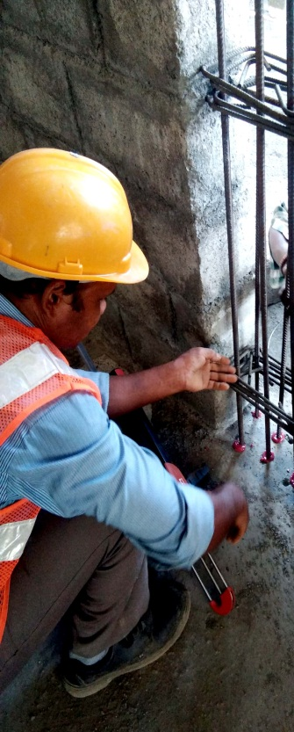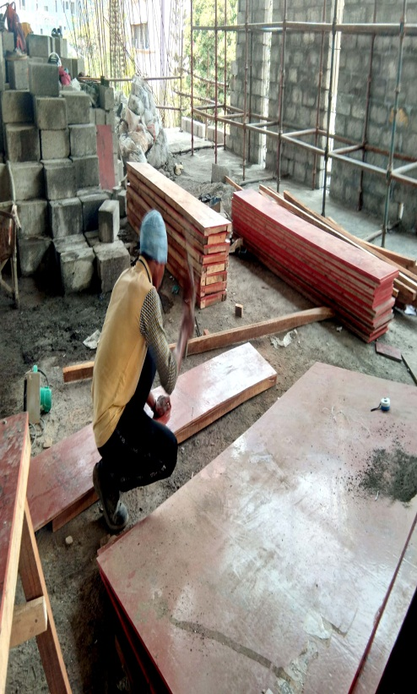Mullions shuttering work. HILTI Re-Bar Grouting work. C.C Block Work.
Pavanputra Infrastrutures
We do not blow our trumpet, but our works do
REPAIRING OF OLD BUILDING.PARIWAR CHSL AT ANDHERI (W) ( AMEYA GROUPS )
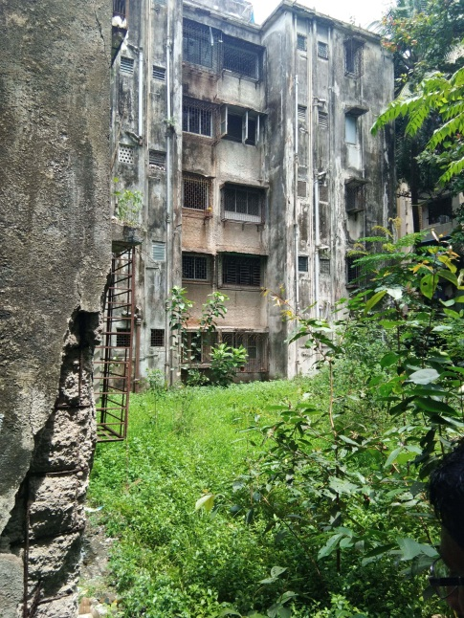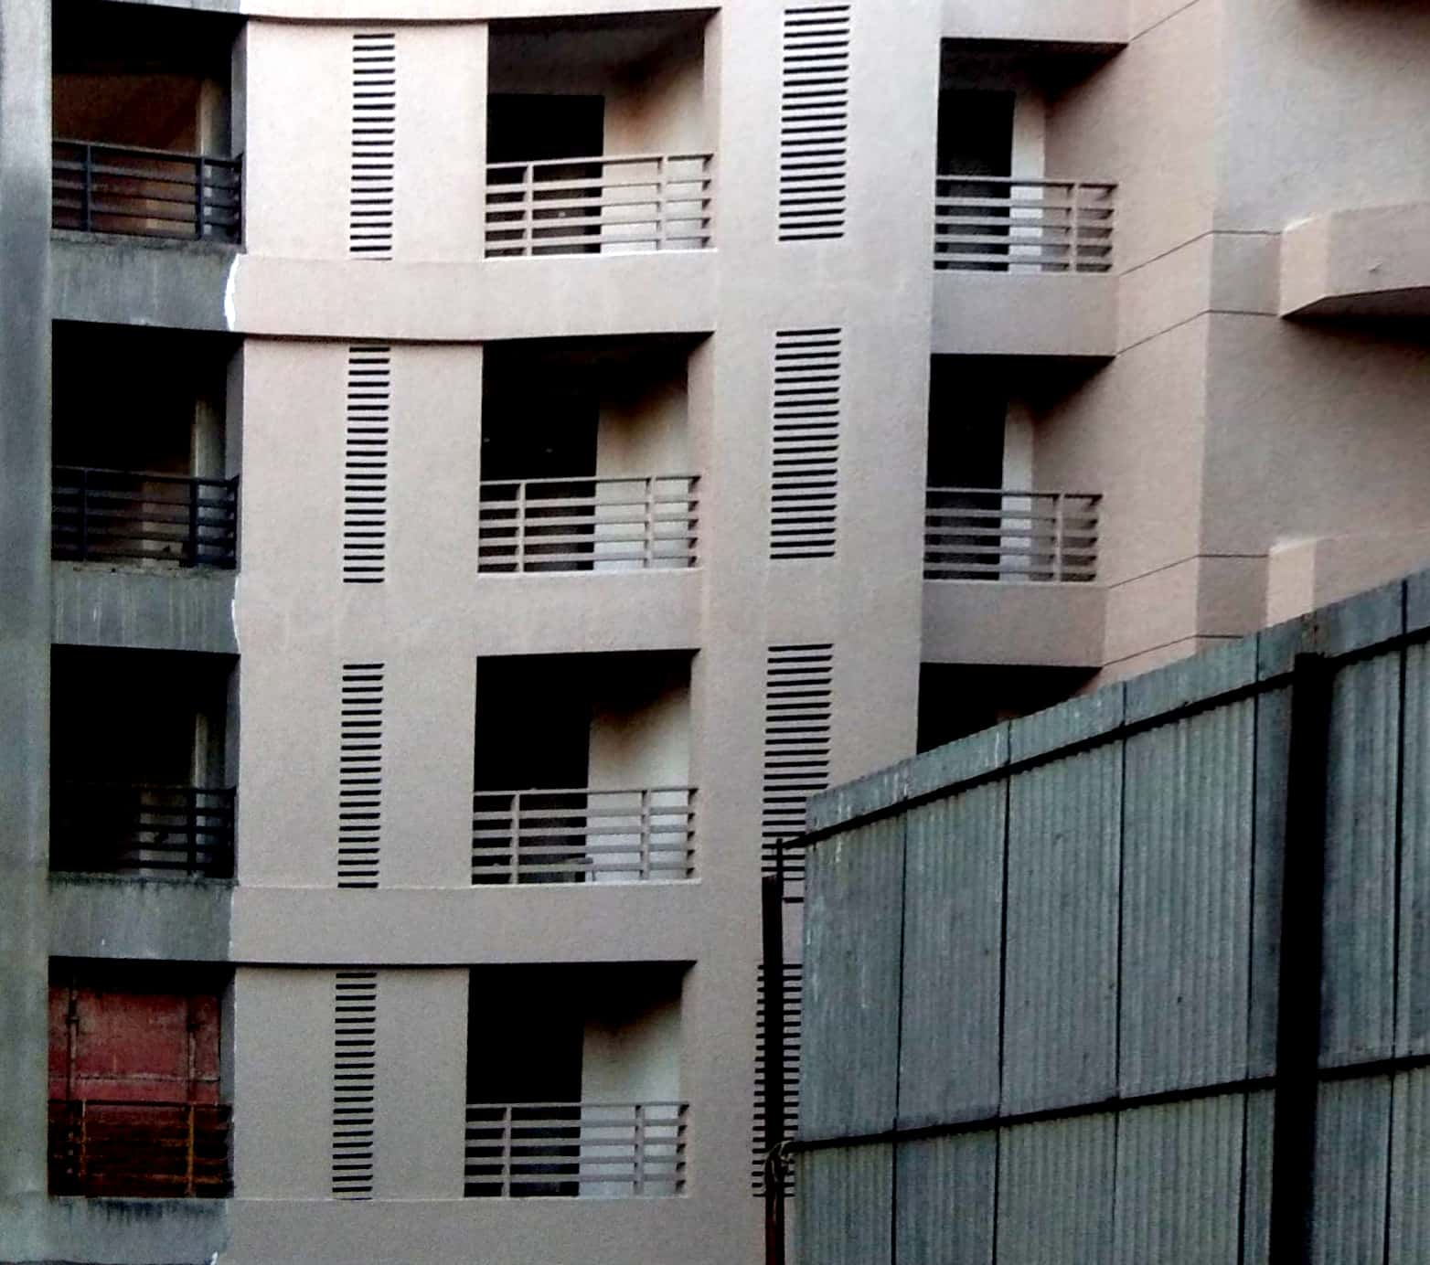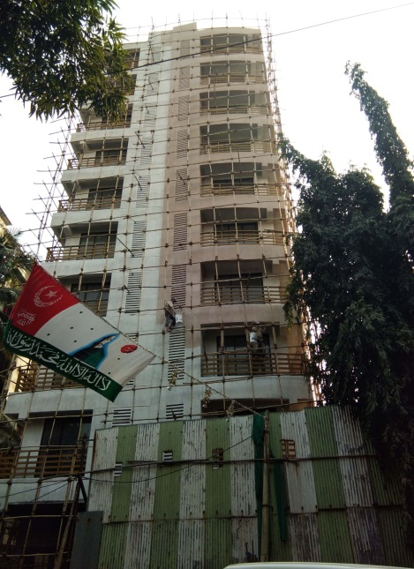
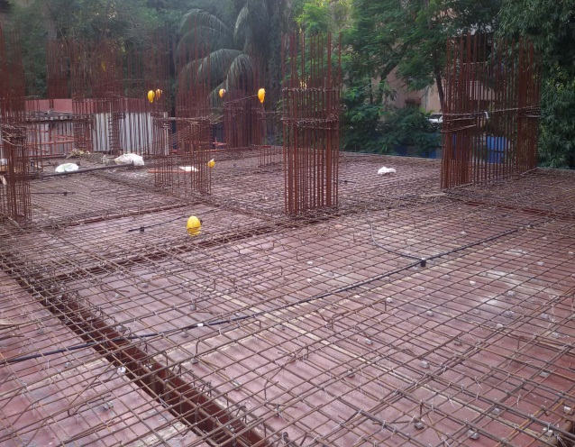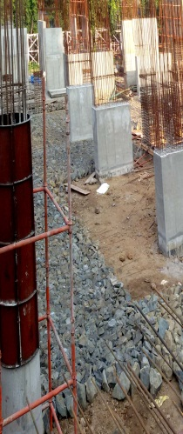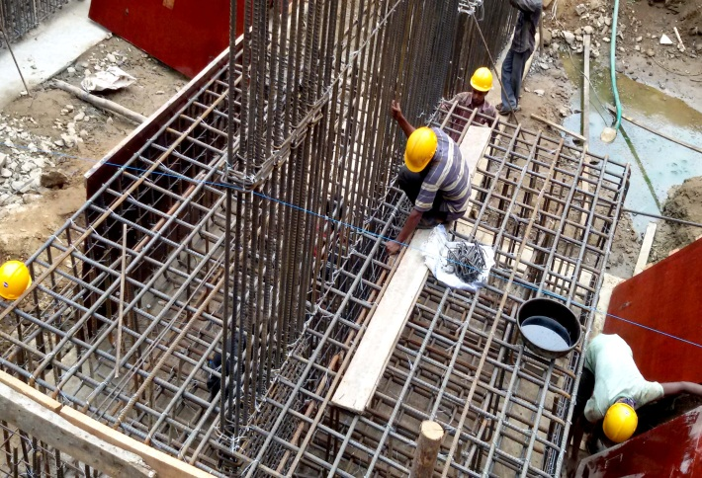
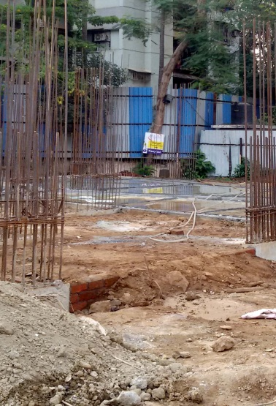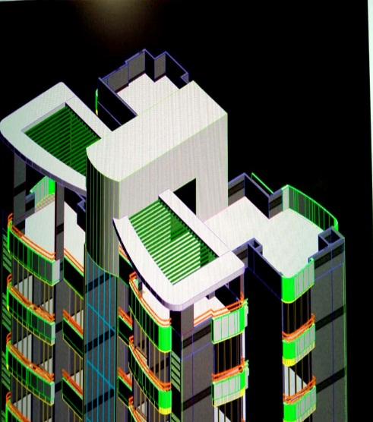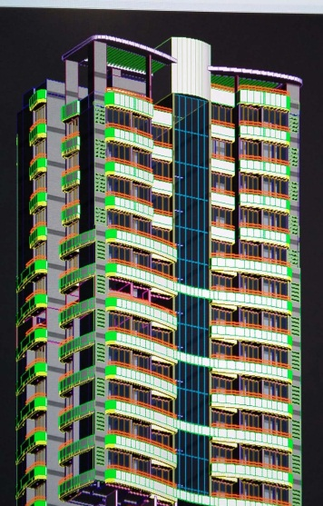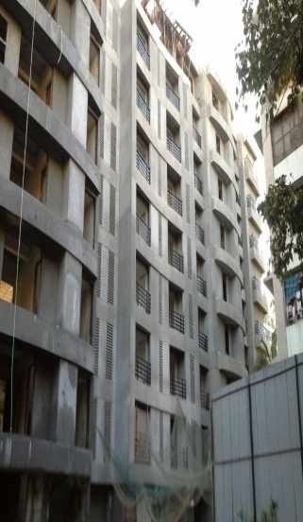 PRIYADRSHINI CHSL.VERSOVA. AT (ANDHERI)(W)(AMEYAGROUPS)
Pavanputra Infrastrutures
We do not blow our trumpet, but our works do

CERTIFICATES
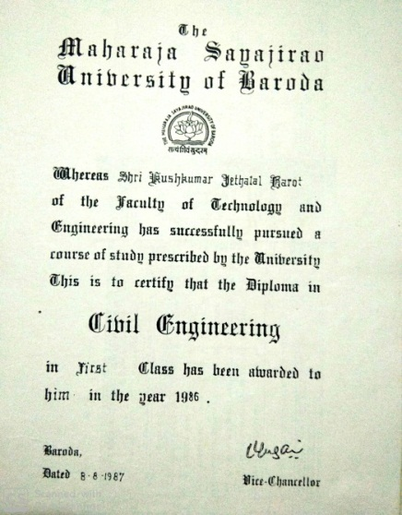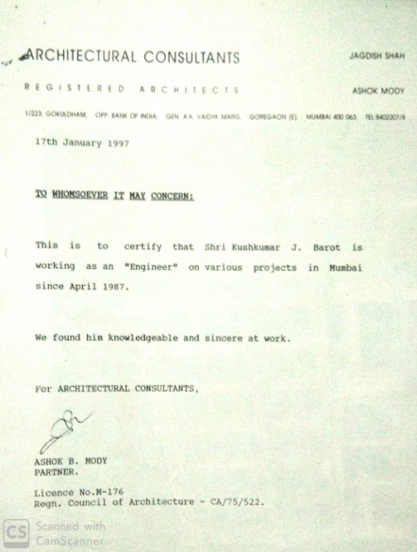
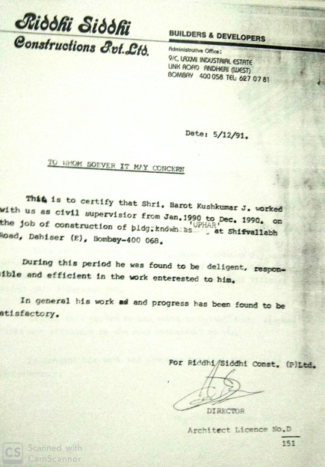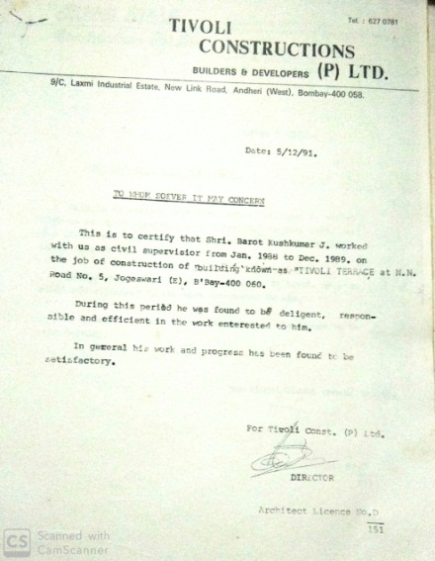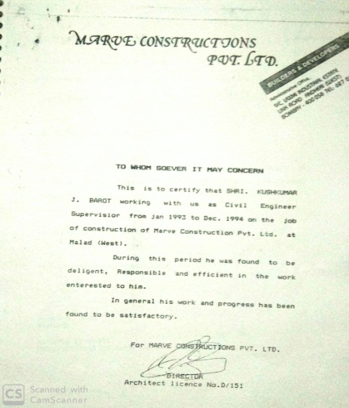
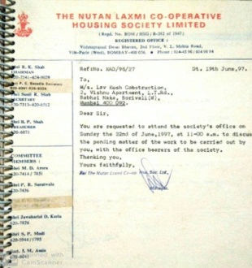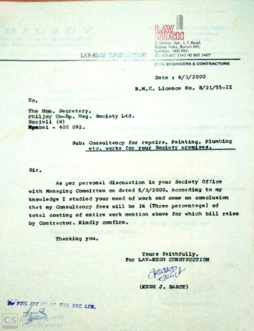
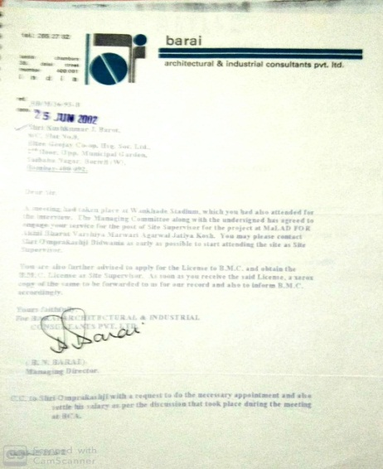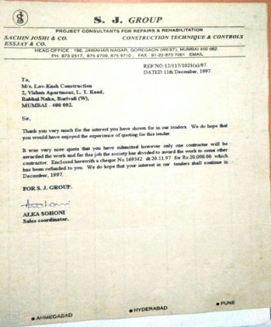

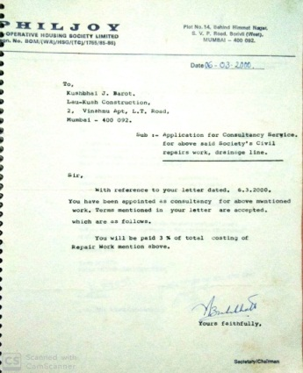

COMPLETED PROJECT UPPER GOVIND NAGER AT MALAD (E)
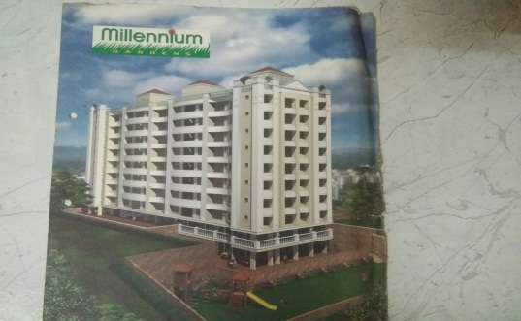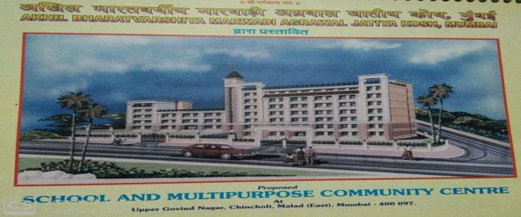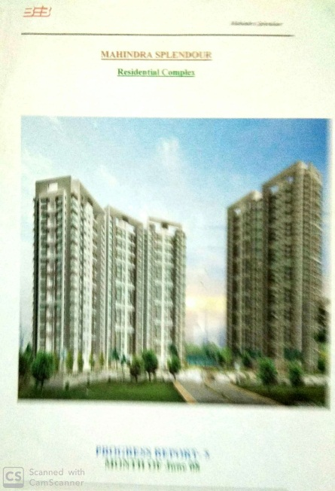 YE AR 1995 TO 1998 YEAR 2003 TO 2005 YEAR 2008 to 2010
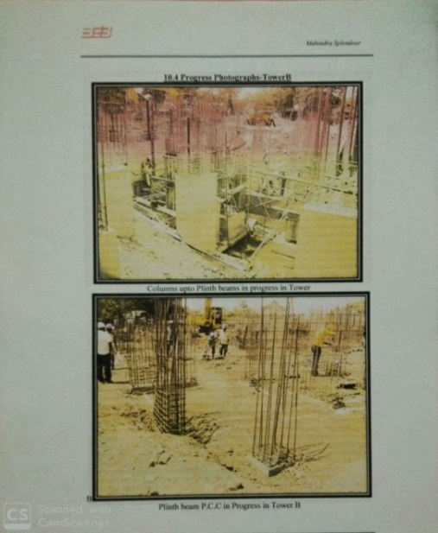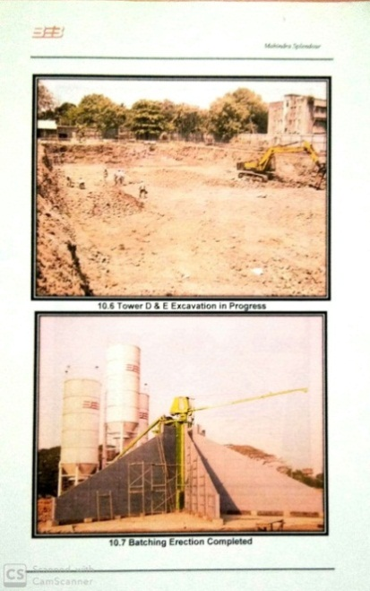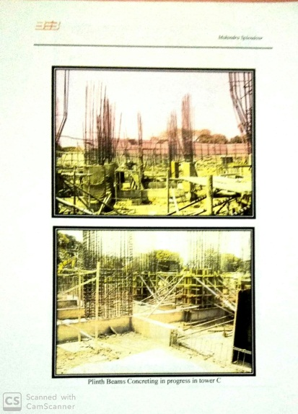
EXISTING REPAIR OF TERRACE WATER-PROOFING.
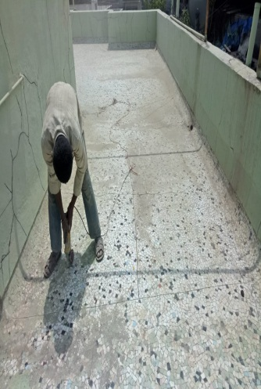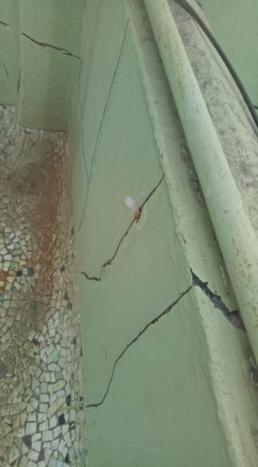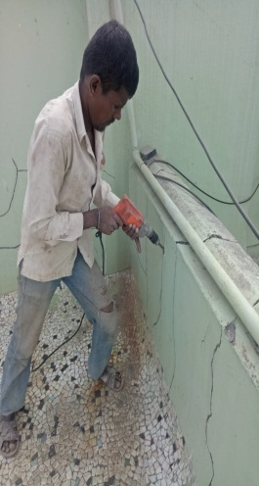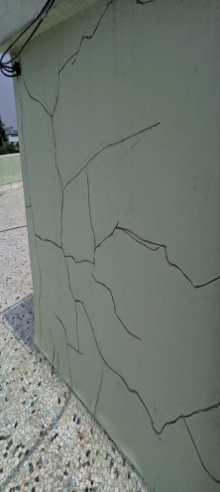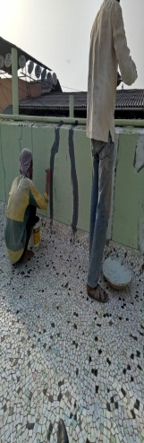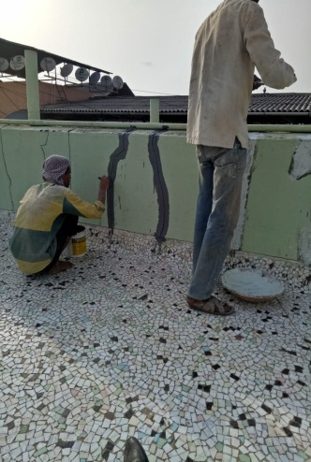

NEW PROJECT 2021 . M/S BHARAT INFRA & ENGG.PVT LTD. Kndivali ( w )
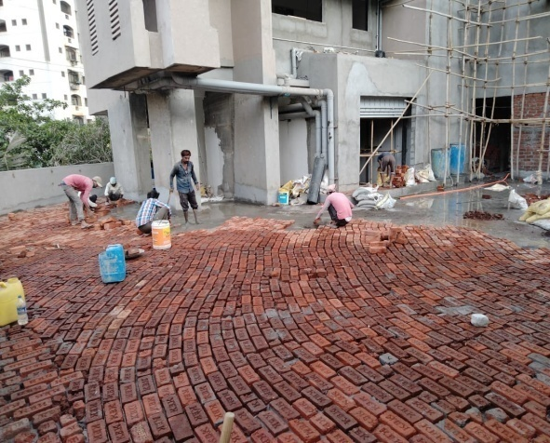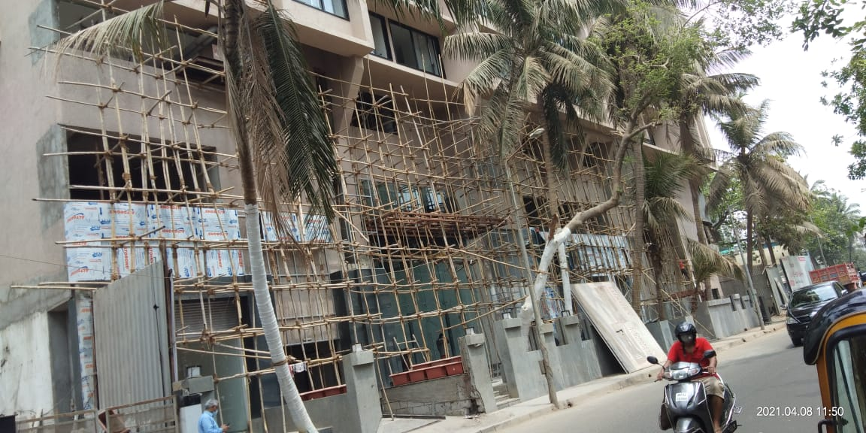

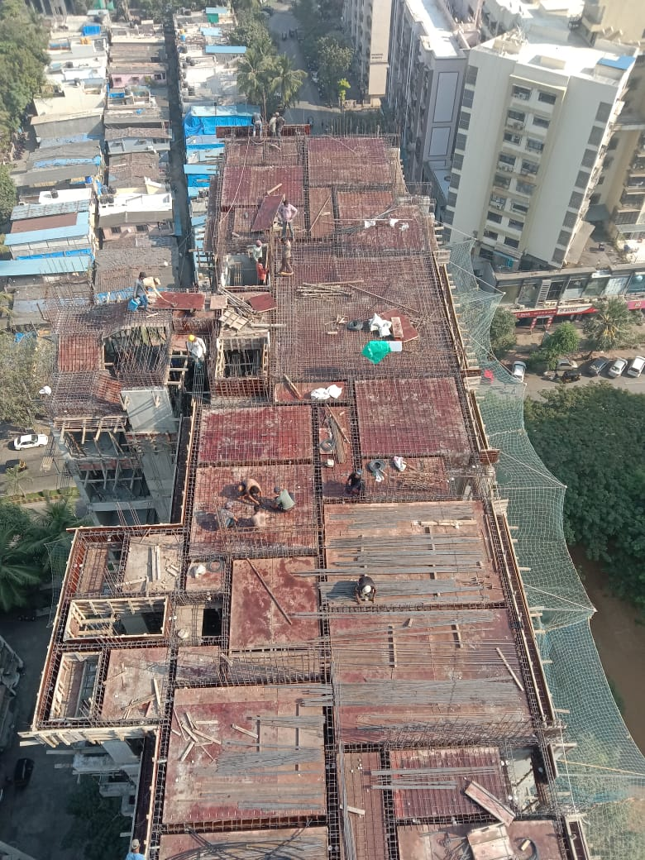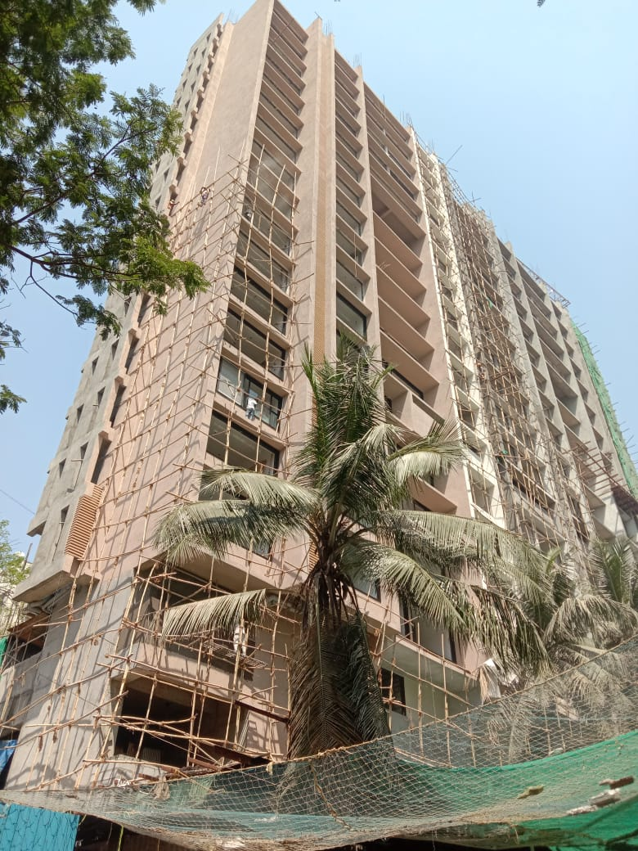
NEW PROJECT 2021TO 2024 . M/S UNWAL INFRA PVT LTD. goregaon ( east)
1) rE-hAB TOWER 22 STORIED rera project = 1,50,000 SQ.FT
2) sale tower = basement + 3 podium + 34 th storied . = 2,50,000 sq.ft.
3) COMMERCIAL PROJECT = 3 LEVEL BASEMENT + 17TH STORIED .( ANDHERI ( E).

Our Esteem Experince
From
1987
To
2024
-----------------------------------------------------
G-47, Veenasantoor , Opp. MCA Garden ,
Saibaba Nagar Ext.Road ,Borivli (w) , Mumbai-400 092
E- Mail : pavanputra.infra@yahoo.com
Contact: 9224488552 www. pavanputra infrastructures.

Site Executive

Or

Inspection

As per B.M.C. Licenced
No. b/21/ss-1

